**Customer Economics Data Design**

16th May 2024

**Overview**

Currently, metrics for customer costs such as Customer Acquisition Costs (CAC), Customer Verification Costs (CVC), and Customer Service Costs (CSC) reside in different tables and are displayed across different looks, creating complexities in consolidation and analysis of these customer costs. This document proposes a solution to combine these costs into a single, streamlined table in databricks.

**Current Challenge**

**Lack of Integration:** The calculations for CAC, CVC and CSC currently reside in separate tables and looks.This then prevents a unified view and tracking of actual total customer costs.

**Looker Dependency:** Current workflow relies on Looker for updating and maintaining separate looks for each customer cost type [in this folder](https://looker.corp.luno.com/folders/2509), leading to having to separately upload these to Anaplan.

**Proposed Solution: Consolidated Customer Costs Table**

The envisioned solution is to integrate all relevant costs into a single, accessible cost table.

This consolidation will allow us to swiftly gauge the financial impact of customer onboarding, acquisition and servicing.

**Key Components of the Consolidated Customer Costs Table**

The table will integrate data from existing data sources including CVC, marketing, compliance, and transactional databases. We will first create 4 different tables for each of the customer types and consolidate these tables into one customer costs table. These tables will look like the following:

**Marketing Costs Table:** This table will store costs related to direct marketing (paid marketing relating to online advertising), promotional campaign costs, and referral campaign costs.

**CVC/CSC Table:** Contains costs related to customer identity verification.

**Compliance Cost Table:** Encompasses costs related to legal and regulatory adherence. Costs incurred up to point of upgrade.

**Transactional Cost Table:** Records costs Net transaction processing costs. These are transaction costs incurred with our providers less transaction income (costs recovered from customers through transaction fees) incurred on upgrade action (first buy/receive).

**Data Flow for the Consolidated Customer Costs**

The tables below illustrate the flow of data from individual cost tables (Marketing, CVC, Compliance, Transactional) into the consolidated Customer Cost table in databricks, which can then be used for reporting.

**CVC/CSC Table**

|  | **Databricks table** | **Look/Explore** | **Cost field** | **User ID field** |
| --- | --- | --- | --- | --- |
| CVC/CSC | analytics.identity.customer_verification_costs | [Link](https://looker.corp.luno.com/explore/luno_databricks/customer_verification_costs) | cost_usd | user_id |
| **Source tables:**  Twilio  PBVerifyIdentity  SmileID  Ubble  Onfido  Asli  Daon  Panacea | base.bitx.vw_users,  base.bitx.otps  base.identity.id_verify  base.identity.smile_id_checks  base.syncubble.syncubble_checks  base.onfido.vw_reports  base.identity.syncasli_checks, base.identity.syncasli_verification_responses,  base.identity.syncasli_liveness_responses  base.identity.syncdaon_checks  base.bitx.vw_users,  base.bitx.otps  For Twilio and Panacea the table base.bitx.otps is used to determine phone query related costs. However, we can not use this table to determine the provider (Twilio or Panacea). Instead, the customer's preferred locale is being used to infer the provider where ZA preferred locale would indicate Panacea costs. |  |  |  |

Verification costs are documented in this [google sheet](https://docs.google.com/spreadsheets/d/1MdXos76HwUFj_aZbWHFPfqxh9Ln51-exfuosAXRyUy0/edit?pli=1#gid=1836517441)).This is maintained by Jonty and Onboarding Ops. Whenever a cost needs to be updated or added, Onboarding Ops does so in this spreadsheet and notifies the data team of the change then the data team updates the pipeline accordingly.

**Marketing Costs Table**

|  | **Databricks table** | **Look/Explore** | **Cost field** | **User ID field** |
| --- | --- | --- | --- | --- |
| Singular | analytics.singular.vw_singular_campaigns | [Link](https://looker.corp.luno.com/looks/15714?toggle=pik) | adn_cost |  |
| Referrals | analytics.bitx.referrals | [Link](https://looker.corp.luno.com/explore/luno_databricks/referrals) | reward_amount_usd | user_id |
| Referrers | analytics.bitx.referrers | [Link](https://looker.corp.luno.com/explore/luno_databricks/referrers) | rr_reward_amount_usd | user_id |
| Promos | analytics.bitx.promos | [Link](https://looker.corp.luno.com/explore/luno_databricks/promos) | amount_usd | user_id |

Example below illustrates how the consolidated marketing costs table could look like (singular data to still be included)

[Notebook](https://luno-prod.cloud.databricks.com/?o=4189090685062816#notebook/2425448889550831/command/2425448889550832)

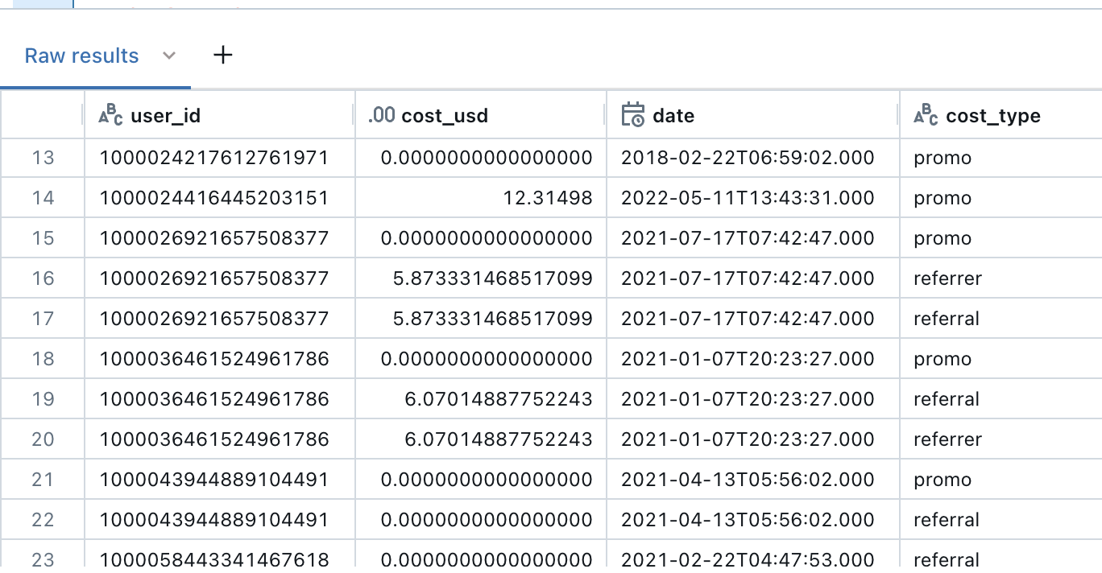

**Compliance Costs Table**

|  | **Databricks table** | **Look/Explore** | **Cost field** | **User ID field** |
| --- | --- | --- | --- | --- |
| Sift | analytics.identity.customer_verification_costs | [Link](https://looker.corp.luno.com/looks/15707?toggle=dat,fil,pik,vis&qid=JwjCI35gLTXk0UPEiso5Hs) | cost_usd where query type is  (sift_query_l0,  sift_query_l1,  sift_query_l2) | user_id |

**Transactions Costs Table**

The current challenge with the transactions costs, the calculation of Transaction Processing Costs (TPC) and Transaction Processing Income (TPI) is done manually and there is a lack of this data in our databases. Currently the total TPI/TPC amounts are captured in the company trial balances to show what we actually pay each month in total, some of which are split by country but not for crypto TPI/TPC. For example, the BusOps team goes into different provider portals and exports all transactions within a month and then determines the TPC/TPI from there.

However the following table does contain some provider transactional costs for PayU_ZA, Stitch_ZA, TrueLayer_GB and monoova_au.

|  | **Databricks table** | **Look/Explore** | **Cost field** | **User ID field** |
| --- | --- | --- | --- | --- |
| Payment Provider Transactional costs | analytics.bitx.payment_provider_transactional_costs | [Link](https://looker.corp.luno.com/dashboards/5764) | calculated_provider_fee_usd | user_id |

**Final Customer Costs Table**

| **Field** | **Description** |
| --- | --- |
| user_id | Unique customer id. |
| cost_usd | Total customer cost derived from the Marketing, CVC, Compliance and Transactions table. |
| datetime | Datetime of when the cost was incurred. |
| cost_type | Indicates cost type such as promo, referral or paid marketing related to online advertising. |